CASE FILE 06
Grip Gaming
Product line: game controllers
Grip Gaming builds controllers that work on consoles and PCs. Gamers are not all the same, and Grip wants a lineup instead of one controller that tries to please everyone.
Your job: Build a lineup of three versions, one for each segment below. For every version, choose its features and set its price. Your goal is the most total profit across all three.
THE MARKET: THREE SEGMENTS
Grip Gaming surveyed people in the Chicago area. The survey split them into three groups. Read the profiles, then give each segment a name.
SEGMENT A  16,000 potential customers | SEGMENT B  5,000 potential customers | SEGMENT C  8,000 potential customers
- Ages 12 to 30, plays a few hours a week with friends  - Needs a second or third controller for guests  - Plays mostly sports and party games  “I just need a backup controller for when friends come over.” | - Ages 15 to 28, plays ranked matches daily  - Watches pro esports and copies their setups  - Has upgraded controllers 3 or more times  “Back paddles are not optional.” | - Parents of gamers ages 6 to 13  - Buying as a gift or a replacement  - Has replaced at least one broken controller this year  “My son has broken three controllers. Three.”
Our name for them: | Our name for them: | Our name for them:
PRODUCT BASICS
Base cost of every version | $15 per controller, before any features are added
Price options | $30 $45 $65 $90 $130 $180 (each version must use one of these prices)
WARM-UP: READ THE DATA FIRST
1. Which segment has the most must-have features (60% or higher)? How many does it have?

2. What is the most expensive feature on the menu? Which segment, if any, says it is a must-have?

3. What is the lowest price at which fewer than half of Segment B would buy?

4. If Grip Gaming sold a version with a Fit of 100% to Segment A at $45, how many people would buy it?

SURVEY RESULTS: WHAT EACH SEGMENT REQUIRES
Question asked: “Which of these would a game controller need to have before you would buy it?”
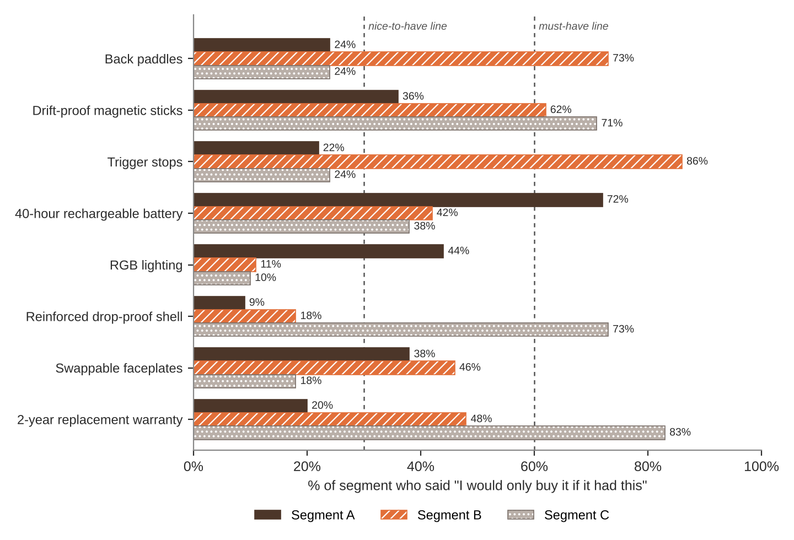
FEATURE MENU
Every feature you add raises your cost per controller. Add a feature to any version you want.
Feature | What it is | Cost to add
Back paddles | Extra buttons on the back for faster inputs | $8
Drift-proof magnetic sticks | Joysticks that never drift or wear out | $10
Trigger stops | Shorter trigger pull for faster shots | $4
40-hour rechargeable battery | No more AA batteries | $6
RGB lighting | Color-changing lights | $3
Reinforced drop-proof shell | Survives drops and throws | $5
Swappable faceplates | Change the look in seconds | $4
2-year replacement warranty | Broken? We send a new one | $7
SURVEY RESULTS: WHAT EACH SEGMENT WILL PAY
Question asked: “If it had everything you need, would you buy it at this price?”
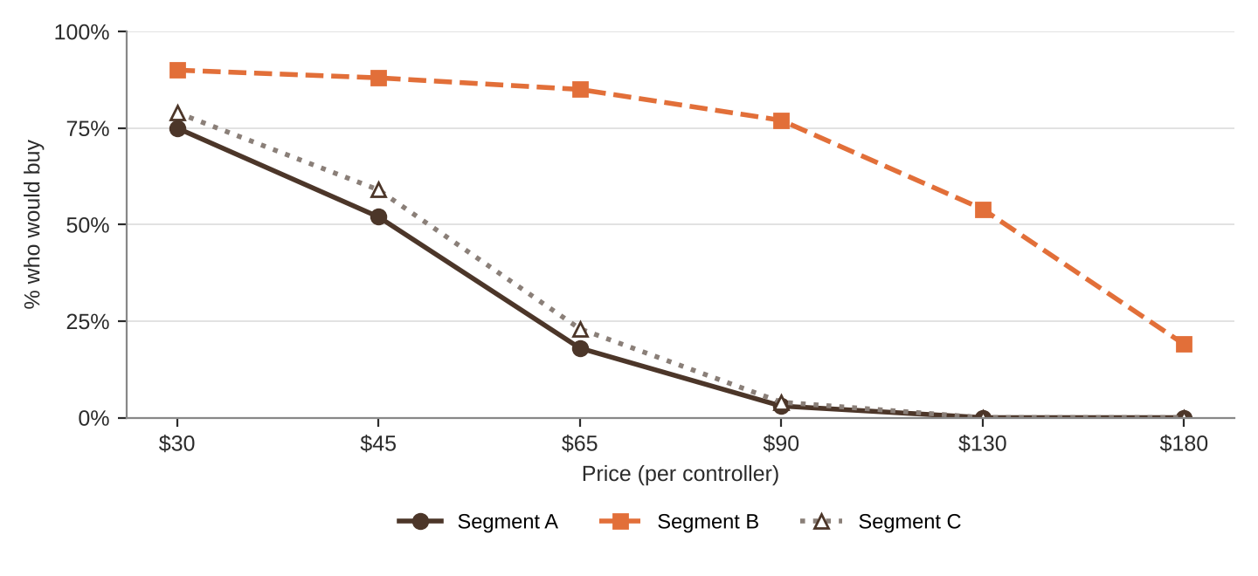
% of each segment who would buy at each price
Price | $30 | $45 | $65 | $90 | $130 | $180
Segment A | 75% | 52% | 18% | 3% | 0% | 0%
Segment B | 90% | 88% | 85% | 77% | 54% | 19%
Segment C | 79% | 59% | 23% | 4% | 0% | 0%
QUICK RULES
Must-have | A feature that 60% or more of a segment requires. Leave one out and that segment's buyers are cut in half. Leave two out and they're cut in half again.
Nice-to-have | A feature that 30% to 59% of a segment requires. Each one you include adds 5% to Fit.
Under 30% | That segment doesn't care. It adds cost and nothing else.
Fit | Start at 100%. Add 5% for each nice-to-have included. Then cut in half for each must-have left out.
Buyers | Segment size × % who would buy at your price × Fit. Round to a whole number.
Profit | Buyers × (Price − Unit cost). Unit cost = base cost + cost of every feature you added.

